THE IMPORTANCE OF DITIGAL SKILLS IN TODAYS WORLD
Digital skills; Are the abilities required to use digital devices, communication applications, and networks to access, manage, and create information.
EXAMPLES OF DITIGAL SKILLS AND THEIR USES
Digital Skill | Primary Uses
1. AI & Automation Literacy | Automating repetitive tasks, generating creative content, and assisting in research or customer service.
2. Data Analytics | Translating raw data into actionable insights to guide business strategies.
3. Digital Marketing & SEO | Building brand awareness, reaching target audiences globally, and driving online sales.
4. Cybersecurity | Protecting digital infrastructure, personal devices, and sensitive corporate data from cyber threats.
5. Cloud Computing | Storing, managing, and accessing data/software over the internet rather than on local hard drives.

IMPORTANCE OF DITIGAL SKILL
- Improve Learning
Digital skills help students access online lessons, educational videos, e-books, and other learning resources, making learning easier and more effective.
- Enhance Research Skills
Students can use the internet to find information quickly, compare sources, and gather data for assignments and projects.

- Improve Communication
Digital skills enable students to communicate with teachers and classmates through emails, messaging applications, and online learning platforms.

- Increase Productivity
Students can complete assignments, prepare reports, and organize their work more efficiently using digital tools.

- Promote Collaboration
Digital platforms allow students to work together on group projects, share ideas, and exchange information regardless of location.

HOW DITIGAL SKIILS IMPROVE EMPLOYMENT OPPORTUNITIES
KEY BOARD SHORTCUTS AND THEIR USES
• Iincrease Job Opportunities – Digital skills enable people to qualify for a wider range of jobs that require the use of computers and technology.

• Improve Productivity – Employees with digital skills can complete tasks faster and more efficiently, making them valuable to employers.

KEYBOARD SHORTCUTS AND THEIR USES.
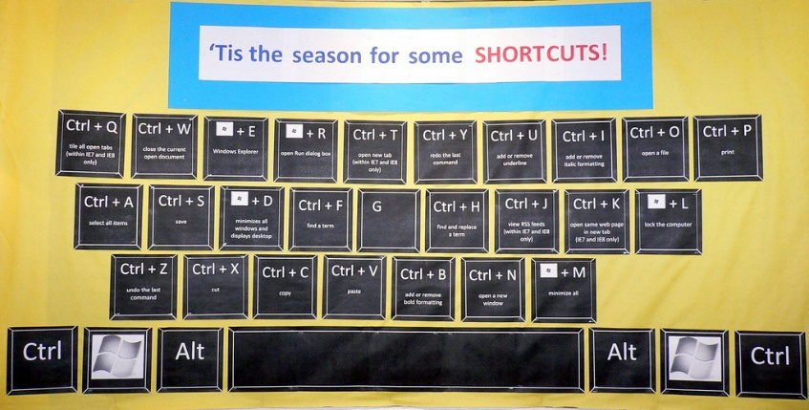
This Photo by Unknown Author is licensed under CC BY-SA
Keyboard shortcuts; Are key combinations that help you perform tasks quickly without using a mouse.
WHY KEYBOARD SHORTCUTS ARE IMPORTANT
• Save time when working on documents.
• Increase productivity and efficiency.
• Reduce reliance on the mouse.
• Make document editing faster and easier.

MISCROSOFT SHORTCUTS WITH THEIR USES

Microsoft Word Keyboard Shortcuts
• Ctrl + C – Copy selected text or item.
• Ctrl + V – Paste copied text or item.
• Ctrl + X – Cut selected text or item.
• Ctrl + Z – Undo the last action.
• Ctrl + Y – Redo the last action.
• Ctrl + A – Select all text in a document.
• Ctrl + S – Save the document.
• Ctrl + P – Print the document.
• Ctrl + N – Create a new document.
• Ctrl + O – Open an existing document.
• Ctrl + B – Make selected text bold.
• Ctrl + I – Italicize selected text.
• Ctrl + U – Underline selected text.
• Ctrl + F – Find a word or phrase in a document.
• Ctrl + H – Find and replace text.
• Ctrl + E – Centre-align text.
• Ctrl + L – Left-align text.
• Ctrl + R – Right-align text.
• Ctrl + J – Justify text.
• Ctrl + K – Insert a hyperlink.
SHORT CUTS THAT ARE IMPORTANT TO STUDENTS
SHORTCUT | USE TO THE STUDENTS
CRTL + C | COPY SELECTED TEXT
CRTL+P | PRINT THE DOCMENT
CRTL+F | FIND THE WORD AND PLACE IN THE DOCUMENT

